Compound Movements in Multi-joint Systems
Compound movements in multi-joint systems almost never have a fixed center of rotation, with no translation. In fact, the principal advantage of compound movements is often that they convert rotations into translations. One can reach out using rotations in the shoulder and elbow. By their nature, joints convert small rotatory movements within the physical joint into large excursions of parts of the bones at some distance from the joint. That allows for substantial amplification in anatomical movements. However, the action that is needed is not a rotation about a fixed point. By spacing joints out between multiple links, one may produce quite large, complex, and nuanced movements of a wide variety of types. We now turn to a consideration of several simple systems that produce compound movements.

Two Link Systems/Linear Movement

A Basic System
Consider a simple system with two links that rotate about a central joint. Such a simple system can already produce linear movement, rotatory movement, and combinations of both. However, to create a linear movement, there must be a precise coordination of the actions in the joints.

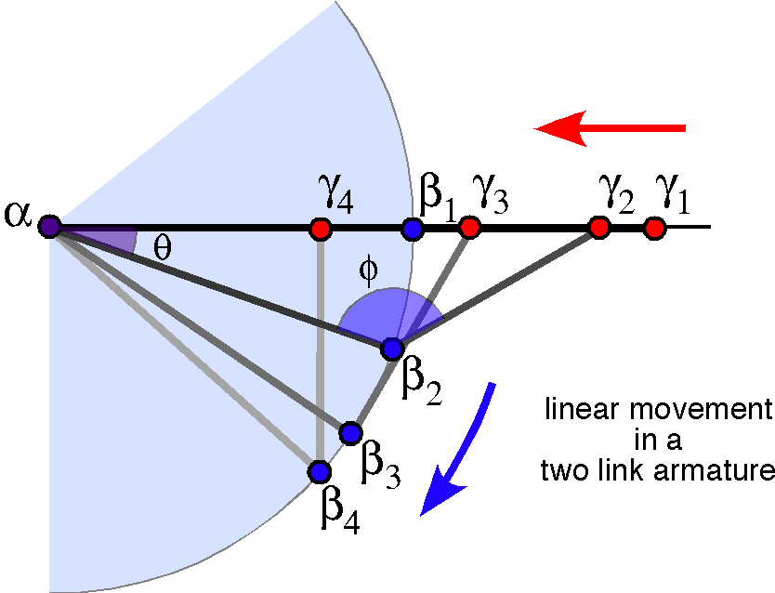

In the above figure, a two link armature has been constructed and compelled to move the distal end of the armature along a straight line extending away from its proximal endpoint. The arrangements of the links are illustrated for successive 30° steps in the orientation of the distal link, . Note that the central joint is compelled to move along a circular arc, because it is of fixed length with a fixed center of rotation at its proximal end. In fact, it can move on a spherical surface, but the situation has been simplified here by constraining it to a plane, because doing so does not fundamentally alter the analysis that that follows. In life, the joint might follow a spherical trajectory. For instance, when drawing back a bowstring in preparation to shoot an arrow, one’s elbow rotates laterally as the string is pulled back. That rotation occurs in the shoulder and it effectively rotates the whole system as a unit.
One can readily see in the figure that the relationships between the locations of the joint and the distal end of the distal link are not simple and the relationships between the angles and are clearly non-linear. In fact, if the distal extremity is drawn further proximally, the joint will reverse the direction of its movement and begin to swing up again. That may be why human arms and forearms are approximately the same length and why their thighs and legs are about the same length.

Describing the System
The first step towards a deep understanding a process is often to describe it as precisely as possible. Therefore, let’s consider how such a two link system might be described.
To start with, let the proximal end of the proximal process, , be fixed. The location of the joint between the links, , and the distal end of the distal link, , are then expressed in terms of and the rotations of the links at and . The vector from to is and the vector from to is .
The orientations of the proximal and distal links can also be written down.
If the ratio of the initial orientations is , then the expression for the orientation of the distal segment can be written in terms of the orientation of the proximal segment.
We can combine these expressions and obtain the description for the distal end of the distal segment in terms of the initial conditions for the armature.
However, the location of the distal endpoint may also be described as lying a given distance in a direction relative to , therefore we can write down its location irrespective of the details of the linkage.
Setting aside rotations of the system as a whole about the line of movement, the linkage lies in a plane defined by the two links. If the distal endpoint moves along a straight line, then the change in its orientation must be about an axis perpendicular to the plane that contains the two armatures. Consequently, the vector of the rotation that changes the orientation of the distal endpoint is the vector of the ratio of the links.
The angle of the quaternion of the rotation, , is the change in angle between the links.
We can write down the expression for the distal endpoint orientation in term of these quantities.
These alternative descriptions lead directly to a pair of equations involving the rotation quaternions.
These equations express the relationships between the rotations at and . Clearly they depend on the lengths of the links and the direction of the movement. If the direction of one link changes, then the direction of the other link must change and the vectors of the rotation quaternions must all lie in the same direction, perpendicular to the plane that contains the two links. Both of the component rotations must be unitary rotations, because the links to not change length, therefore they must be in opposite directions in order to keep the distal endpoint, , on a line through the proximal endpoint, .
We can write out the rotation quaternions in trigonometric form as follows.
This means that we can rewrite the expression for the relationship the locations as follows.
We were able to simplify the expression because the axis of rotation is perpendicular to the moving link. Consequently, the expression uses twice the angle in the original expression.

A Calculation
Now, let us consider some calculations to illustrate the foregoing points. Start with a situation like that in the following figure.

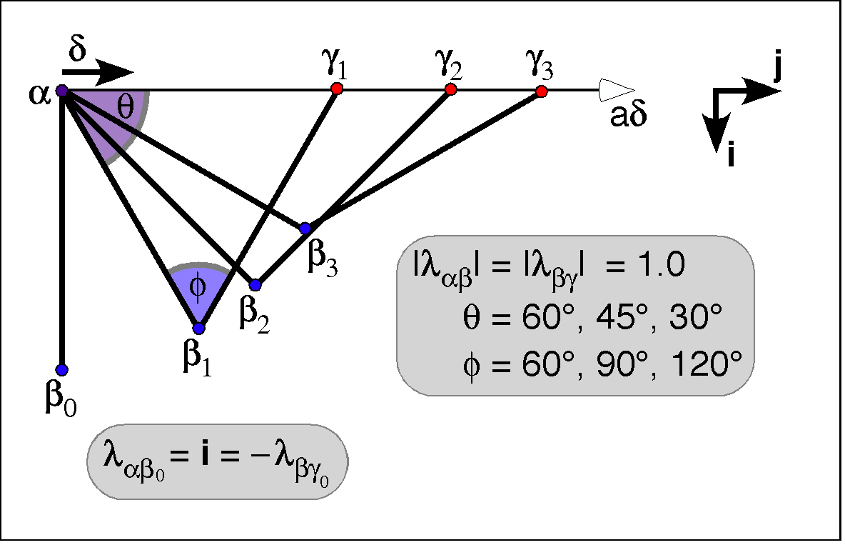

The two links are of equal length (1.0) and the initial positions for the two links are along the i-axis.
The proximal link is rotated 30°, 45°, and 60° to generate , respectively. That means that the interior angle at is 60°, 90°, and 120°, respectively. Note that if the angle that the first link swings through is , then the following relationships hold.
It is straightforward to compute the values of .
The distal endpoints may be similarly computed.

Tempo
Because of the geometry of the described situation, it is clear that the distal endpoint of the armature traces a straight line that passes through as it moves. The dynamics of the proximal link are fairly simple, but the dynamics of the distal link are substantially more complex.
If the angular velocity is uniform at , then the angular velocity at is twice as fast and the linear velocity along the line of movement is sinusoidal with the fastest movement at the beginning of the movement. To make the movement uniform along the line of movement the angular excursions must follow a time course like the arcsine of time. Normal anatomical movements follow neither trajectory. They tend to accelerate to a maximum, hold that value for most of the excursion, and then decelerate to a finish.

Division Between Rotation and Translation
It is clear that the component movements are both rotations and yet the compound movement contains a large translation component. There must also be a rotation component, because the orientation of the distal endpoint changes. Translation does not change orientation, therefore there must be a rotation. We can compute the magnitude of the rotation by taking the ratio of the orientations. In this case, we know that the rotation is entirely in the plane of the armature and the distal link goes from being directly vertical (−i) to being directly horizontal (j), therefore the rotation component has an angular excursion of 90° about the –k axis. The total translation is i + j, a distance of . The distance traveled during the rotation is radians or, since the radius is 1.0, a distance of 1.57. Consequently, there are comparable amounts of rotation and translation.
In this instance, it makes most sense to view the movement as a translation that sweeps along the circular arc centered on the proximal end of the proximal segment as the rotation occurs about that traveling center of rotation. Curiously, the angular excursion of the rotation is 90°, but the joint at opens from 0° to 180°. So the joint between the links experiences a 180° rotation. This situation shows how the way you view a structure can determine what is seen.

Transverse Movements
Clearly, as set up, it is possible to make movements that are perpendicular to the reaching movement that we have just considered. However, when we look at examples of jointed systems like that considered here, they do not make such movements in the middle joint. In both our upper and lower extremities, the central joint in the limb is essentially constrained to move in a single plane, that is, they are hinge joints. When we look closely, there is a small amount of play, but that is mostly to make the joint more effective by locking the knee or allowing rotation at the wrist. This observation leads one to ask why the system is so constrained.
Both the hip and shoulder joints are ball and socket joints. They allow a wide variety of trajectories and thereby set the plane in which the knee or elbow joint will rotate. The ankle/foot and the wrist/hand are also able to move in multiple planes to set the orientation of the end of the limb, the part that usually engages the rest of the world.
When we examine the musculature, it becomes apparent why this arrangement is used. The intrinsic instability of the proximal joint requires a great deal of musculature to control the limb’s orientation. In the shoulder we find the large masses of the latissimus dorsi, the trapezius, rhomboid and levator scapulae muscles to the scapula and the supraspinatus, infraspinatus, and teres major, subscapularis, and minor muscles from the scapula to the humerus to control the posterior aspect of the joint and the pectoralis major and minor, coracobrachialis, and biceps to control the anterior aspect. The serratus anterior acts through the scapula and the deltoid acts both anteriorly and posteriorly. In the hip, we have all the glutei, the piriformis, the gemmeli, obturators, tensor fascia lata, the quadriceps muscles, and iliopsoas, the hamstrings and several adductors operating around the joint. Because of the masses of these muscles, it is necessary to keep them close to the axis of the body, to reduce the angular momentum of inertia of the limb. By making the middle joint a single axis joint, it is possible to make do with two sets of muscles, the flexors and extensors. They are still massive, but that mass in closer to the body axis than the joint. Compared to the mass of muscles needed to control the proximal joint, they are small.
It is possible to allow the distal joint to move about multiple axes, because the mass that needs to be moved is comparatively small, the hand or foot. The muscle can be placed proximal to the joint and the muscles can be relatively small. Most of the muscles that control the fingers are in the proximal forearm and similarly for the toes and the calf. In animals that need to move very fast, the wrist and hand are elongated and there is minimal muscular mass, giving a long lever arm with a comparatively low angular moment of inertia.
It is necessary to have a greater freedom of movement in the distal end of the armature to partially compensate for the shifts of orientation that are enforced by the arrangement of the more proximal joints. That is especially so in apes and monkeys, which are able to grip objects with their hands. It is not sufficient to get the hand to the right place, but it also has to be correctly oriented. One could do without. A person with a fused wrist can still do most things, but the movement to obtain the correct rotation must occur in the proximal joint, often by expending substantially more energy to lift the entire upper limb.
One way around that would to be to allow the middle joint to rotate about the axis of the distal link. In fact that is approximately what happens. The movement in the joint that moves the forearm is about a single axis, but there is an axis of rotation for the wrist that passes through the distal end of the ulna and the proximal end of the radius. The physiologically relevant movement is the rotation of the distal end of the radius about the distal end of the ulna. It is complemented by rotations about an axis parallel with the long axis of the radial facet (abduction/adduction) and an axis parallel with the long axis of the radial facet (flexion/extension). The wrist cannot move about intermediate axes because of the oblong shape of the facet. Moving about an oblique axis, intermediary to the flexion/extension and the abduction/adduction axes, would force the joint to separate, which is restrained from happening by the ligaments about the joint. As a consequence, there are three separate axes of rotation without a ball and socket joint. That arrangement is more stable while allowing for a great deal of control of orientation with much less muscle mass.
The proximal end of the radius lies in the elbow joint, where it is essentially a ball and socket joint, but the annular ligament effectively restrains movements in that joint to rotation about an axis nearly parallel with the ulna shaft. It is actually not necessary to the wrist joint. It can be surgically removed by cutting off the proximal end of the radius with minimal consequences for wrist movement. The principal loss is probably a loss of stability when punching with the hand. Even then, the fascial ligament between the two bones and the distal annular ligament are strong restraints on that type of movement unless a considerable force is placed behind the punch.
In summation, even though there are theoretical possibilities of generating transverse movements by movements in the central joint of the armature, there are mechanical reasons why it is not a good solution to the generation of such movements. The normal anatomical means of generating such movements is to rotate the proximal link in the proximal joint and allow the flexion/ extension in the central joint to move the distal end of the distal link to trace out a circular arc.
Movements in the distal joint are made more stable by fractionating the movement into several axes that travel with the bones and are fixed relative the local landmarks. So, the abduction/adduction axis for the wrist in anatomical position allows the wrist to move in a parasagittal plane when the distal end of the radius is rotated 90° about the ulna. Each component joint is essentially a hinge joint, therefore requires much less muscle to control its movements, but, added together, we can obtain a considerable amount of movement in multiple directions.

